INTRO:
In soccer, people argue all the time about whether a team deserved its results or just got lucky. We wanted to answer that with Premier League data. We used expected goals (xG), which is how many goals a team should have scored based on the chances it got. If a team scores way more than its xG, it's either really good at finishing or just lucky. Our idea was simple: luck shouldn't happen again the next season, but skill should. This matters because clubs spend a lot of money on teams and players after one good year, and it helps to know if that year was real.
We looked at 13 seasons of Premier League games (2013-14 to 2025-26, 4,940 games). We compared each team's goals to its xG and used a few stats tests to see which gaps were bigger than normal luck. Here's what we found. The chances a team creates explain most of where it finishes in the table. Home teams win more because they get more chances, not because they shoot better. About 1 in 7 team-seasons were off their xG by more than luck would explain, and about a third of that carried over to the next season.
DATASET:
We got our data from football-data.co.uk, which has a file for every Premier League season. Each row is one game with the date, the two teams, the final score, and how many shots and shots on target each team had. We downloaded every season from 2000-01 to 2025-26. The site didn't have real xG, so we made our own: every shot on target counts as 0.32 goals, because that's how often a shot on target goes in across the whole league. We only used 2013-14 and later because the site changed how it counted shots on target that year. That left 13 seasons and 4,940 games. This data works well for our question because every season is complete (380 games, 20 teams) and every game has both the score and the chances behind it.
ANALYSIS TECHNIQUE:

The main number we looked at is goals minus xG. If it's positive, a team scored more than its chances were worth. If it's negative, it scored less. A season is only 38 games, so some of that gap is just random. To figure out which gaps were real, we used a bootstrap, which means we reshuffled each team's games 10,000 times to see how much the gap could change by chance. We used linear regression to see how closely goals follow xG at home and away, and how well xG predicts points. We used t-tests to compare home and away teams. Last, we checked if a team's gap one season matches its gap the next season, since that's the real test of luck vs skill. These methods make sense for soccer because there aren't many goals and results are noisy, so you need to check if a pattern is bigger than luck before you trust it.

RESULTS:
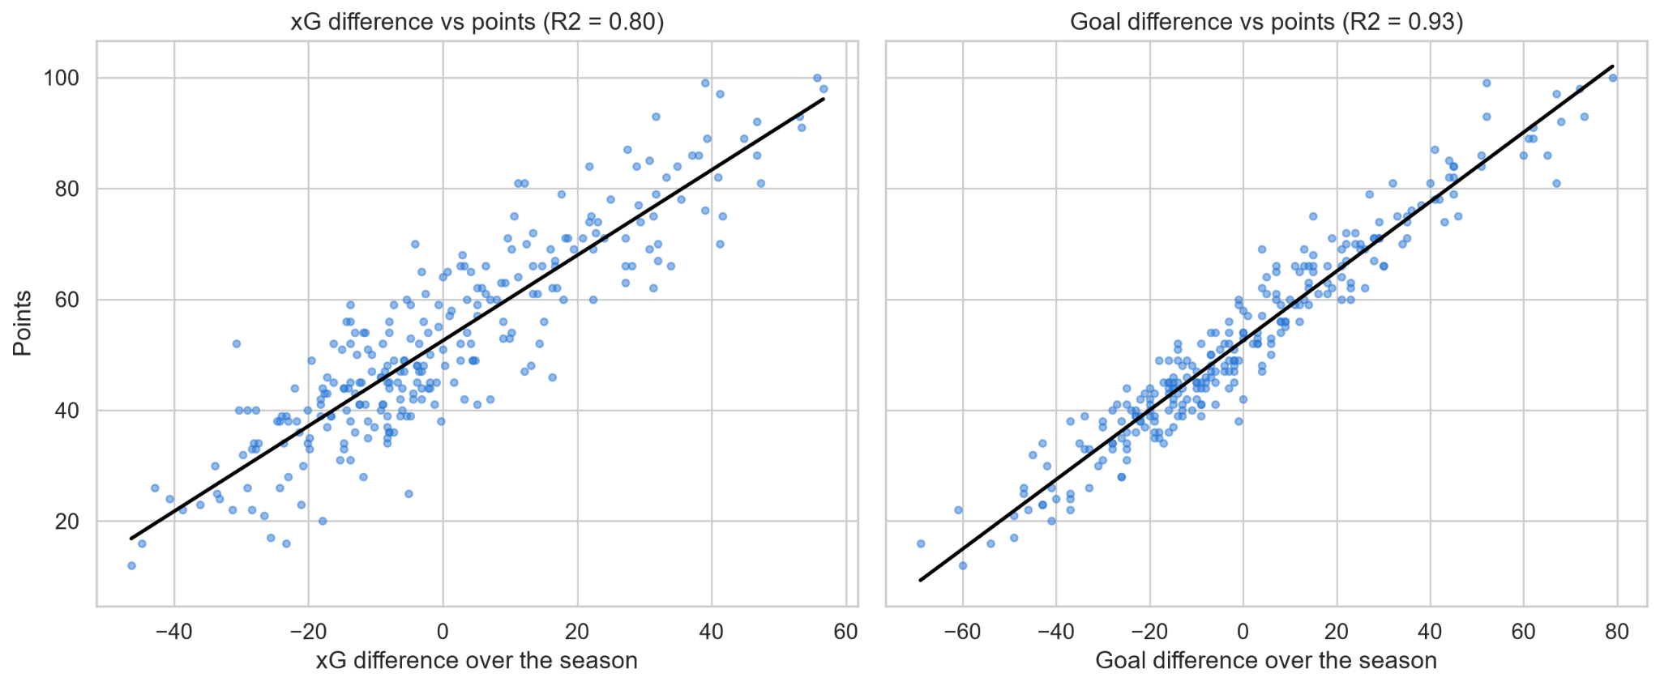
Chances decide most of the table. A team's xG difference (chances made minus chances allowed) explains 80% of its points (Figure 1). Actual goal difference explains 93%, so finishing still matters a little. Some teams were way off their xG. Man City in 2013-14 scored 102 goals from 76 xG (+26), and Norwich that same year scored 28 from 47 (−19). For the ten biggest gaps, even the bootstrap range never reaches zero, so those gaps weren't just luck (Figure 2). Overall, 38 of 260 team-seasons (about 15%) were off by more than luck would explain, when luck alone would only give about 5%. The ranges are pretty wide though, usually about 23 goals, so one season doesn't tell you much about one team.
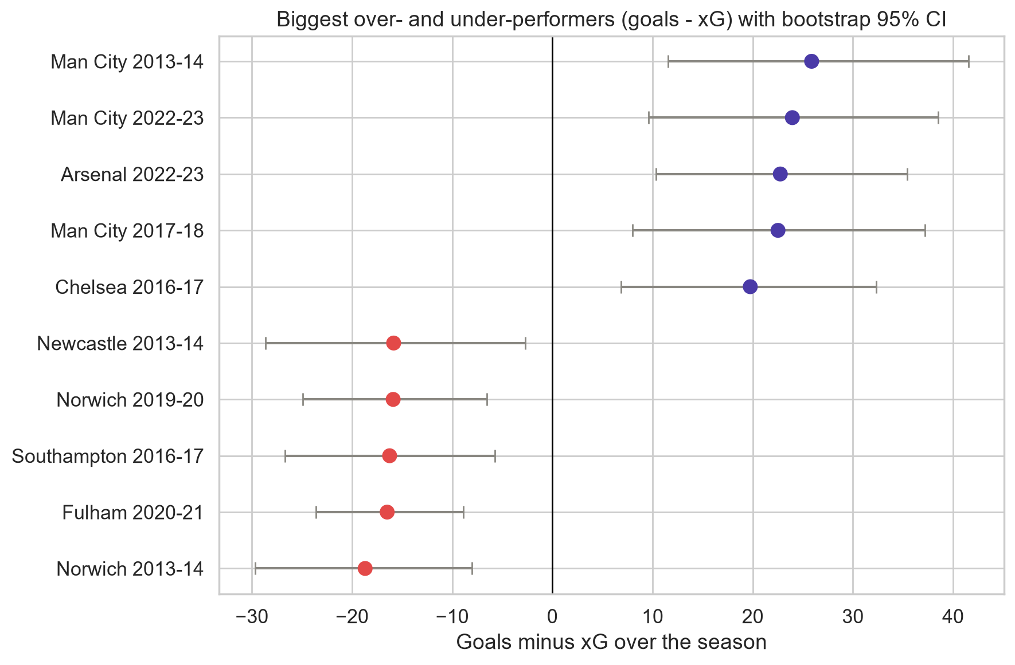

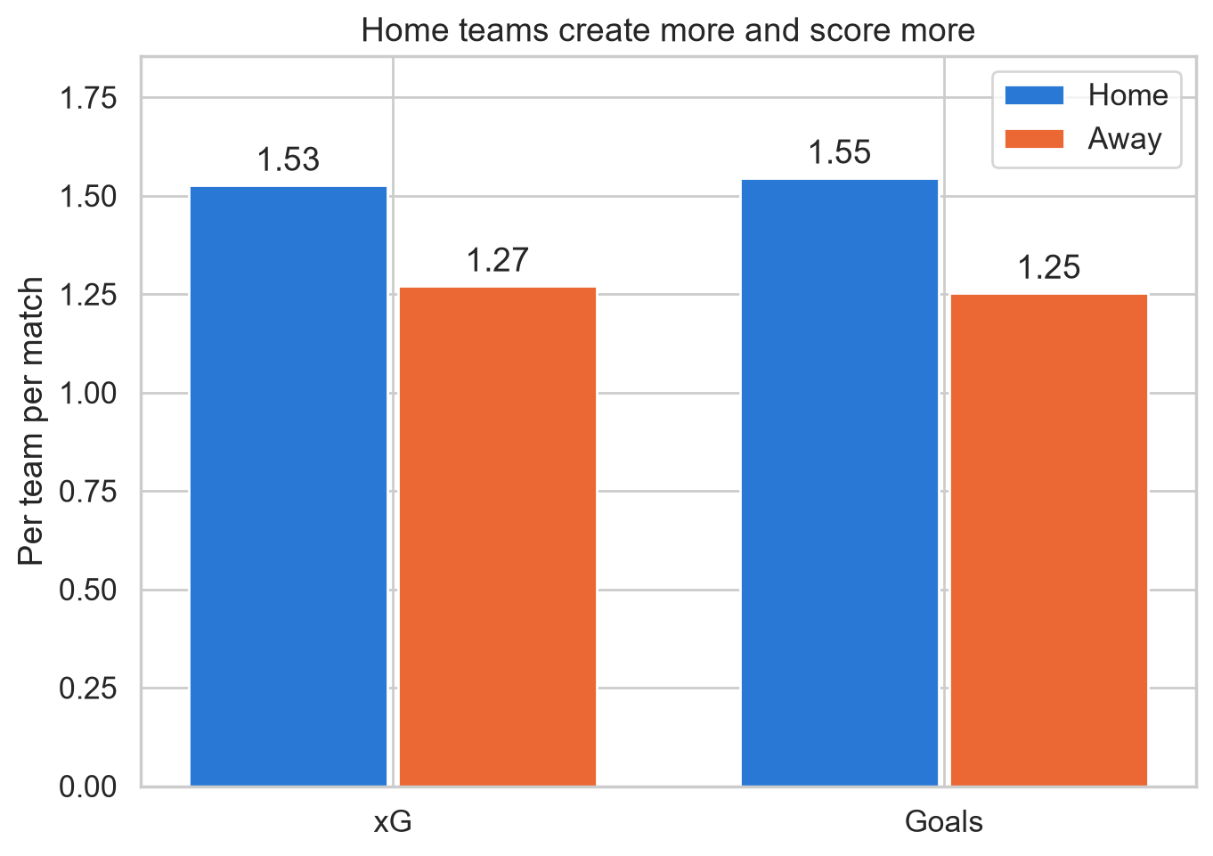
Beating xG kind of repeats. A team's gap one season is linked to the next (r = 0.33, p < 0.001, Figure 4), mostly in home games. About a third carries over and the rest goes away

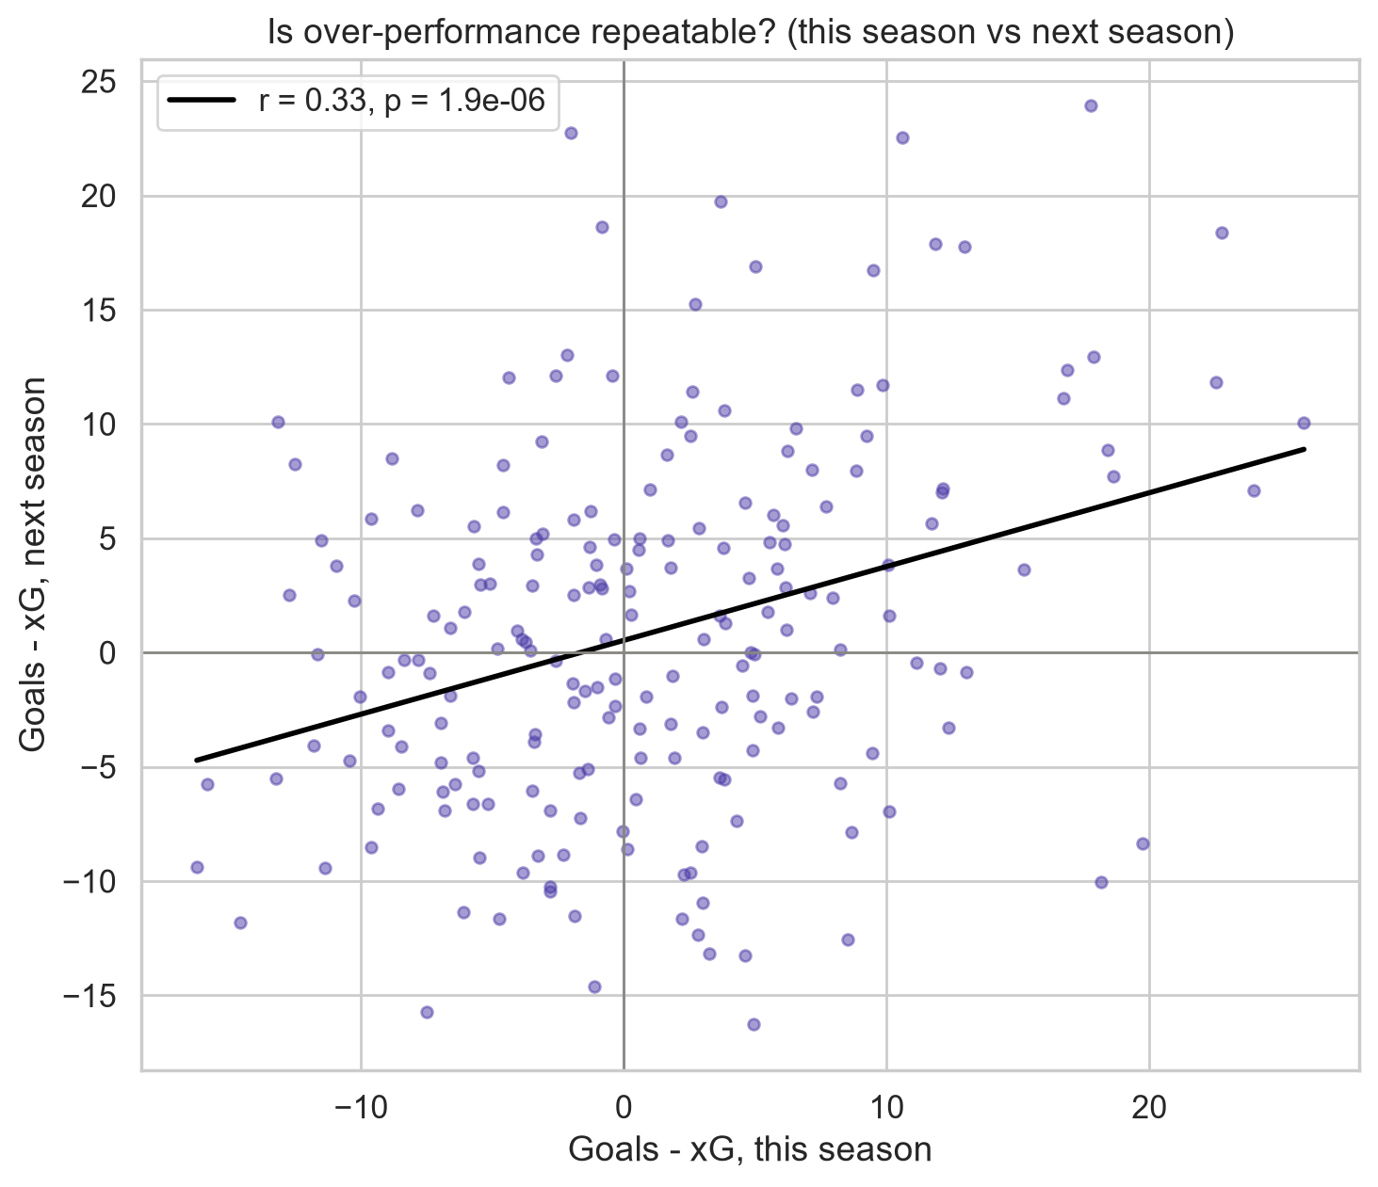

Judge teams by the chances they create. If a team beat its xG by a lot, expect about two thirds of that to disappear next season, so don't pay for one hot year.

TECHNICAL
We scraped every season's E0.csv link with BeautifulSoup (2000-01 to 2025-26). Some 2003-05 rows had extra columns, so we read them with spare columns and kept only the ones we needed. We dropped one blank row, fixed types and mixed date formats, and checked for duplicates (none), 380 games and 20 teams per season. The xG columns were empty, so we used shots on target × 0.320. The share of shots on target dropped from 57% to 33% in 2013-14, so we only kept 2013-14 onward. We split each game into two team rows and built a team-season table (260 rows).
We used a bootstrap (10,000 resamples, seed 42) because season gaps aren't normally distributed. Separate home and away regressions with an interaction term showed no slope difference (p = 0.15). Breusch-Pagan showed the spread grows with xG, so a Poisson model would fit better. Paired t-tests (plus Wilcoxon) compared home and away, and Pearson and Spearman correlations on 204 team pairs tested persistence. Dropping games with 4+ goals changed nothing (p = 0.96).
We planned to use real xG, but the site didn't have it. Our proxy treats every shot on target the same and ignores missed shots, and since the 0.320 rate came from the same goals, league goals and xG match by design. Persistence is probably a bit high because good teams beat their xG every year. Next time we would use real shot-level xG (like Understat) and adjust for team strength.

